

Title: “All I Want for Christmas is You”
Artist: Mariah Carey
Genre: Pop, Holiday

Album: Merry Christmas
Listen to the song on YouTube!

Directions:
Rip off the paper below with the link to the song. Type the link on your computer.
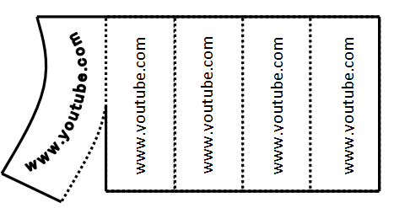
http://www.youtube.com/123



www.youtube.com

Or, take a paper from the envelope. The lyrics to the song are in English and Japanese!

